Rube Goldberg Project
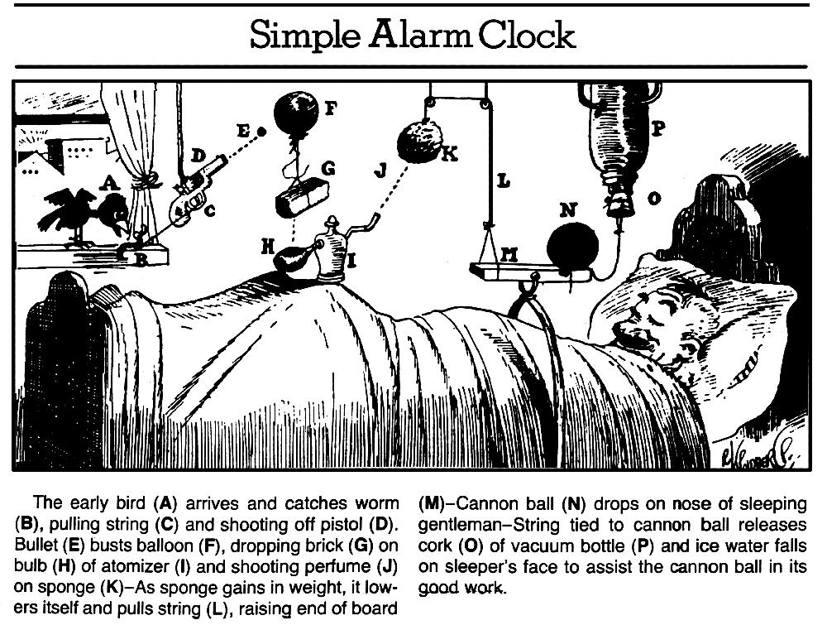
In groups of 3, you will design and build a complex contraption that performs a simple task. In addition, you must demonstrate the application physics concepts and support this with calculations to explain the motion or transfer of energy for each step.
Completed projects will include the following:
- The contraption
- A typed guide, explaining the process of each step (at least 12), the physics concept involved, and the necessary calculations (at least 6).
- A drawn, or computer drafted blueprint and/or a video detailing the contraption

Specific Requirements
1. Must fit on a space roughly 2 ft. x 2 ft x 3 ft (You can go outside of that for the start or finish step)
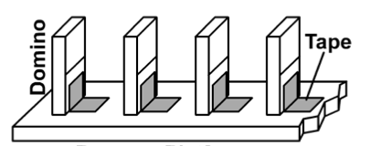
2. The contraption must be started with only one action, and must continue on its own for at least 20 seconds, and no more than two minutes. It must be able to be reset in a reasonable amount of time.

3. Must have at least 12 steps. A working step is defined as a triggering that causes an action. It is completed when one object transfers energy to another object.
4. Must have at least 2 different simple machines represented.
5. An object must be raised/projectiled at least 12 inches.
6. You may use up to 1 electrical devices, but only if they are activated by action of the contraption. These devices must be battery powered.
7. You may not include any of the following:
- Explosives, fire, CO₂ cartridges, smoke, knives, razor blades, dangerous flying objects, or dangerous/toxic chemicals are not allowed. When in doubt, ask before building.
- Your machine may not incorporate ANY living animals, e.g. hamsters, parrots domesticated goldfish, feral goldfish, miniature lap giraffes, what if donkeys, etc…
- Pre-made goldberg mechanisms, such as the game "Mouse Trap"
8. Awards/Bonus Points will be awarded for:
  - Greatest number of physics concepts/calculations incorporated
  - Most creative overall theme or task.
  - Greatest number of steps, longest running.
9. You must provide number calculations for at least 6 of the steps, including mechanical advantage for 2 simple machines. (no repeat calculations). Below is a list of topics we will be covering as we build our machines.
10. Your rube needs to work at exhibition!!! This is the most important requirement. We may also attempt to have each rube in the class trigger the adjacent rube at the exhibition so it is imperative that yours works everytime.
Concept you are able to demonstrate/calculate | Associated concept for  Challenge Extension
Free Fall or Projectile horizontally launched | Projectile launched at an angle
Inertia (Newton’s First Law) | Moment of Rotational Inertia
Mechanical Advantage of simple machines | Efficiency
Work | Power
Gravitational Potential & Kinetic Energy | Elastic Potential Energy
Conservation of Energy | Transfer of energy using Electromagnetism, Chemical Reaction, or another creative way
Conservation of Momentum | Impulse
Velocity | Acceleration
Force | Pressure
Uniform circular motion | Torque

Challenge Extensions
The challenge extension on this project requires you to incorporate more advanced concepts into your contraption and occasionally complete extra coursework in order to be able perform the associated calculations for 4 additional steps, in addition to the 6 need to be explained with a calculation. Those steps should come from right column. The challenge extension can be done by one individual in the group or by all members. You don’t receive any bonus points on the project for completing the challenge extension, but it may allow you to get bonus points on quizzes or a test.
Another fun challenge extension is to design your rube for semi-permanent installation on the wall in the hallway, in a manner that passersby could enjoy it long after we have our exhibition.
Schedule
Task | Target Due Date | Actual Due Date | Completed?
Project Brainstorm | ------ | Thurs 9/29
Week 1: Group Plan and Materials List | Thurs 10/6
Week 2: Base, Storage Box, and Materials - Begin Construction | Wed 10/12
Week 3: Blueprint - Final Design | Wed 10/19
Week 4: Draft Report w/ Calculations | Fri 10/28
Week 5: Refinement
Week 6: Working Final Contraption | Fri 11/4
Exhibition | Wed 11/9

Initial Brainstorm
- Using rubegoldberg.com/rube-tube or your own search, find a video of a rube and make a list of at least 6 different elements of the contraption and describe how they work.

2. Visit the DP of a sophomore that posted their rube with a description and a video and critique their design. What is cool about it? What could have been done better?

3. What is a cool idea for the final step of your rube???

